Spinner Task 5 Task Answers:
Technically, since there is not statement about the spinner experiment lacking bias, there are endless possibilities that are correct answers to the questions below (which I will discuss more in my critique). For the sake of clarity in this answer rubric, I will assume that the spinner experiment was found or is assumed to lack bias.

Calculate the experimental probabilities of landing on each section of the spinner:
To calculate the experimental probabilities, or p-values, first take the count of the total amount of times the spinner landed on a particular dollar amount and divide it by the total amount of spins made in the experiment (100). The experimental probabilities are outlined in the chart below:

Dollar amount awarded from spin | $0 | $100 | $200 | $300 | $400 | $500 | $600
Count of total times the spinner lands on particular dollar amount awarded | 30 | 10 | 15 | 20 | 10 | 10 | 5
Experimental probability or p-value | 0.30 | 0.10 | 0.15 | 0.20 | 0.10 | 0.10 | 0.05

Potential Student Error:

Student assumes that the spinner has an equal chance of landing on each dollar amount (1/7 chance for each amount awarded).

Dollar amount awarded from spin | $0 | $100 | $200 | $300 | $400 | $500 | $600
Count of total times the spinner lands on particular dollar amount awarded | 30 | 10 | 15 | 20 | 10 | 10 | 5
Experimental probability or p-value | 0.143 | 0.143 | 0.143 | 0.143 | 0.143 | 0.143 | 0.143

I do not anticipate this to be a common error, as the spinner tasks leading up to this one has students seeing various spinners and discussing how the % area of each dollar award segment dictates the theoretical probability that the spinner will land on that segment each spin.

Use these probabilities to draw what the spinner would look like (you can use GSP to create the Spinner).
First, before drawing, one should calculate the angle measure required from the radius of the spinner circle for each spinner segment, which we can do via the following:

$$Area of Circle=πr^{2}$$
$$Area of Circle Sector=\frac{θ}{360}πr^{2}$$

$$\left(assuming θ is in degrees as this is 9th grade curriculum\right)$$

$$pvalue=\frac{Area of Circle Sector}{Area of Circle}$$

$$pvalue=\frac{ \frac{θ}{360}πr^{2}}{πr^{2}}$$

$$pvalue=\frac{θ}{360}$$

$$360*pvalue=θ$$

Dollar amount awarded from spin | $0 | $100 | $200 | $300 | $400 | $500 | $600
Count of total times the spinner lands on particular dollar amount awarded | 30 | 10 | 15 | 20 | 10 | 10 | 5
Experimental probability or p-value | 0.30 | 0.10 | 0.15 | 0.20 | 0.10 | 0.10 | 0.05
$θ$ (p-value * 360°) | 108° | 36° | 54° | 72° | 36° | 36° | 18°

Now, one can use these angle measurements to depict a spinner as follows:
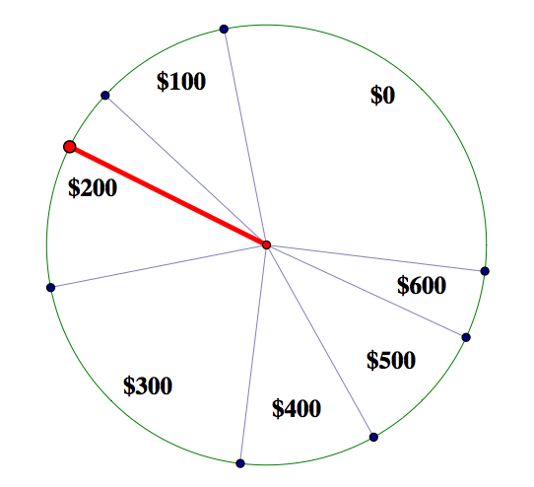
Potential Student Error:
Student assumes that the spinner has an equal chance of landing on each dollar amount (1/7 chance for each amount awarded).

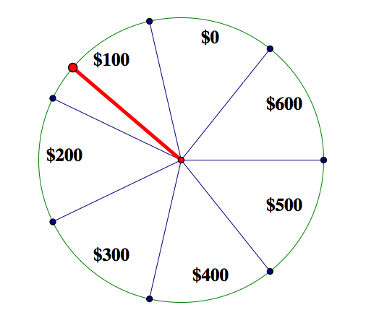

- Calculate the average amount of money a person would expect to receive on each spin of the spinner.
To calculate the average amount of money a person would expect to receive on each spin, find the total dollar amount that would have been awarded in the 100 spins in the experiment. After finding this amount, find the mean value by dividing the total amount by 100.
Dollar amount awarded from spin | $0 | $100 | $200 | $300 | $400 | $500 | $600
Count of total times the spinner lands on particular dollar amount awarded | 30 | 10 | 15 | 20 | 10 | 10 | 5
Winnings | $0 | $1000 | $3000 | $6000 | $4000 | $5000 | $3000

$$Total \$ Won=\$0 + \$1000 + \$3000 + \$6000 + \$4000 +\$5000 + \$3000 = \$22,000$$
$$\frac{Average \$ Won}{Spin}= \frac{Total \$ Won}{\# of Spins}=\frac{\$22,000}{100 spins}=\frac{\$220}{Spin}$$

Some students might realize that they can calculate the same value by taking the probability or p-value for each dollar amount awarded and multiply it by the actual dollar amount awarded. After, they would sum of each of these products. This is called the expected value.

Dollar amount awarded from spin | $0 | $100 | $200 | $300 | $400 | $500 | $600
Count of total times the spinner lands on particular dollar amount awarded | 30 | 10 | 15 | 20 | 10 | 10 | 5
Experimental probability or p-value | 0.30 | 0.10 | 0.15 | 0.20 | 0.10 | 0.10 | 0.05
P-value * Dollar amount awarded from spin | $0 | $10 | $30 | $60 | $40 | $50 | $30

$$\frac{Average \$ Won}{Spin}=\$0 + \$1000 + \$3000 + \$6000 + \$4000 +\$5000 + \$3000 = \frac{\$220}{Spin}$$

I would encourage you to talk about why both of these methods yield the same results ($220) and ask the class to come up for a definition of what expected value is based upon the activity.

Potential Student Error:
Student simply adds all the different dollar amounts awarded and divides by the total number of available prizes (7), this will yield the same results if the student continues to view the spinner as having a 1/7 chance of landing on each prize value as the theoretical probability.

$$Total Available Prizes=\$0 + \$100 + \$200 + \$300 + \$400 +\$500 + \$600 = \$2,100$$
$$\frac{\$2,100}{7 Possible prizes per spin}=\frac{\$300}{Spin}$$

- Calculate p(at least $400) on your first spin.
To calculate the probability that one spin lands at a value of at least $400, one can perform the following calculations:

$$p\left(at least \$400\right)=p\left(\$400\right)+p\left(\$500\right)+p\left(\$600\right)$$
$$p\left(at least \$400\right)=0.10+0.10+0.05=0.25$$

$$p\left(at least \$400\right)=1.0-\left(p\left(\$0\right)+p\left(\$100\right)+p\left(\$200\right)+p\left(\$300\right)\right)$$
$$p\left(at least \$400\right)=1.0-\left(0.30+0.10+0.15+0.20\right)=1.0-0.75=0.25$$

It might be a good idea to have students see both methods and discuss why they arrive at the same answer. Students should discuss which method would be more efficient to use. What method would they use if calculating p(at least $200) and why? I think it is important to discuss this as a class as there will be problems in the future (like the commonly used birthday problem) that are much more efficiently calculated by finding the probability of an event not happening. This will benefit students in the future and help them navigate the conceptual understanding of hypothesis testing and Type I/Type II errors.

Potential Student Error:
Students might simply add up the amount of prizes available that are valued at $400 or more and divide by the total count of available prizes to arrive at a solution of 3/7. This would only be appropriate if the probability of each prize occurring was the same value.

Students might also have reading comprehension issues and calculate only the probability of prizes that are over $400:
$$p\left(at least \$400\right)=p\left(\$500\right)+p\left(\$600\right)$$
$$p\left(at least \$400\right)=0.10+0.05=0.15$$

$$p\left(at least \$400\right)=1.0-\left(p\left(\$0\right)+p\left(\$100\right)+p\left(\$200\right)+p\left(\$300\right)+p(\$400)\right)$$
$$p\left(at least \$400\right)=1.0-\left(0.30+0.10+0.15+0.20+0.10\right)=1.0-0.85=0.15$$

Students might also be confused and multiply probability values instead of adding them:
$$p\left(at least \$400\right)=p\left(\$400\right)*p\left(\$500\right)*p\left(\$600\right)$$
$$p\left(at least \$400\right)=0.10*0.10*0.05=0.0005$$

This is most likely occurring as students are simply using a memorized procedure for calculating the probability of multiple independent events occurring. If this solution is found, discuss with the student if the solution makes sense with the spinner. Does it make sense that for each spin one has less than a 1% chance of obtaining $400, $500, or $600? As a class, you should discuss that this solution actually found the probability that one would be awarded a prize of exactly $400 on the first spin, exactly $500 on the second spin, and exactly $600 on the third spin. As an extension, you might ask the class to attempt to find the probability that one would obtain a $400, $500, and $600 prize in any order on 3 spins in a row, which would be found via the following:
1st Spin | 2nd Spin | 3rd Spin | Probability of Combination
$400 | $500 | $600 | p($400)*p($500)*p($600) = 0.1*0.1*0.05 = 0.0005
$400 | $600 | $500 | p($400)*p($600)*p($500) = 0.1*0.05*0.1 = 0.0005
$500 | $400 | $600 | p($500)*p($400)*p($600) = 0.1*0.1*0.05 = 0.0005
$500 | $600 | $400 | p($500)*p($600)*p($400) = 0.1*0.05*0.1 = 0.0005
$600 | $400 | $500 | p($600)*p($400)*p($500) = 0.05*0.1*0.1 = 0.0005
$600 | $500 | $400 | p($600)*p($500)*p($400) = 0.05*0.1*0.1 = 0.0005
Sum of all Combinations (probability of spinning a prize of $400, $500, $600 in any order three prizes in a row) |  |  | 0.0005*6 = 0.003 = 0.3%

- If you land on $300 on the first spin, calculate p(sum of your first two spins is at least $600).
To calculate the probability that one lands on a prize of $300 on the first spin, one must first find all iterations that result in a total prize across 2 spins of $600 or more and then add up the probability:
1st Spin | 2nd Spin | Total Prize $ | Probability of Combination
$300 | $0 | $300 | p($0) =0.3
$300 | $100 | $400 | p($100) =0.1
$300 | $200 | $500 | p($200) =0.15
$300 | $300 | $600 | p($300) =0.2
$300 | $400 | $700 | p($400) =0.1
$300 | $500 | $800 | p($500) =0.1
$300 | $600 | $900 | p($600) =0.05
Sum of probabilities of total prizes of $600 or more |  |  | 0.2+0.1+0.1+0.05 = 0.45 or 45%
1-Sum of probabilities of total prizes of $600 or less |  |  | 1-(0.3+0.1+0.15) = 1-0.55 = 0.45 or 45%

Potential Student Error:
Student may read this problem as calculate the probability that one spins $300 on the 1st spin AND the total prize of two spins is $600 or greater. I would anticipate this mistake in my student teaching classroom as I had many ELL students and students that were weak in the area of reading comprehension. I would anticipate we would have to discuss question working on this one.
1st Spin | 2nd Spin | Total Prize $ | Probability of Combination
$300 | $0 | $300 | p($300)*p($0) = 0.1*0.3 = 0.03
$300 | $100 | $400 | p($300)*p($100) = 0.1*0.1 = 0.01
$300 | $200 | $500 | p($300)*p($200) = 0.1*0.15 = 0.015
$300 | $300 | $600 | p($300)*p($300) = 0.1*0.2 = 0.02
$300 | $400 | $700 | p($300)*p($400) = 0.1*0.1 = 0.01
$300 | $500 | $800 | p($300)*p($500) = 0.1*0.1 = 0.01
$300 | $600 | $900 | p($300)*p($600) = 0.1*0.05 = 0.005
Sum of probabilities of total prizes of $600 or more |  |  | 0.02+0.01+0.01+0.005 = 0.045 or 4.5%
Probability of Landing on $300 on the 1st Spin-Sum of probabilities of total prizes of $600 or less |  |  | 0.1-(0.03+0.01+0.015) = 0.1-0.055 = 0.045 or 4.5%
Potential Error: 1-Sum of probabilities of total prizes of $600 or less (Student must remember, our initial value is within the set of spinning a 3 first) |  |  | 1-(0.03+0.01+0.015) = 1-0.055 = 0.945 or 94.5 (Incorrect way to calculate this. This number is actually the probability that one spins and lands on any value on the 1st spin and a value greater than $200 on the 2nd spin)

To perform this calculation, one must sum the probabilities of all combinations with $300 that add up to a prize of $600 or more with 2 spins as shown in the table below:

Another student error can occur if the student assumes that the probability of each prize amount is equivalent (as has been previously discussed.)
1st Spin | 2nd Spin | Total Prize $ | Probability of Combination
$300 | $0 | $300 | p($0) =1/7
$300 | $100 | $400 | p($100) =1/7
$300 | $200 | $500 | p($200) =1/7
$300 | $300 | $600 | p($300) =1/7
$300 | $400 | $700 | p($400) =1/7
$300 | $500 | $800 | p($500) =1/7
$300 | $600 | $900 | p($600) =1/7
Sum of probabilities of total prizes of $600 or more |  |  | 1/7+1/7+1/7+1/7 = 4/7
1-Sum of probabilities of total prizes of $600 or less |  |  | 1-(1/7+1/7+1/7) = 1-3/7 = 4/7

1st Spin | 2nd Spin | Total Prize $ | Probability of Combination
$300 | $0 | $300 | p($300)*p($0) = 1/7*1/7 = 1/49
$300 | $100 | $400 | p($300)*p($100) = 1/7*1/7 = 1/49
$300 | $200 | $500 | p($300)*p($200) =1/7*1/7 = 1/49
$300 | $300 | $600 | p($300)*p($300) = 1/7*1/7 = 1/49
$300 | $400 | $700 | p($300)*p($400) = 1/7*1/7 = 1/49
$300 | $500 | $800 | p($300)*p($500) = 1/7*1/7 = 1/49
$300 | $600 | $900 | p($300)*p($600) = 1/7*1/7 = 1/49
Sum of probabilities of total prizes of $600 or more |  |  | 1/49+1/49+1/49+1/49 = 4/49
Probability of Landing on $300 on the 1st Spin-Sum of probabilities of total prizes of $600 or less |  |  | 1/7-(1/49+1/49+1/49) = 7/49-3/49 = 4/49
Potential Error: 1-Sum of probabilities of total prizes of $600 or less (Student must remember, our initial value is within the set of spinning a 3 first) |  |  | 1-(1/49+1/49+1/49) = 49/49-3/49 = 46/49  (Incorrect way to calculate this. This number is actually the probability that one spins and lands on any value on the 1st spin and a value greater than $200 on the 2nd spin)

- Calculate p(sum of two spins is $400 or less).
To calculate, find all spin values that result in $400 or less and calculate the probability of the combination of the 2 spins by finding the product of the probability of each individual spin. Sum all results that have a prize value of $400 or less.
1st Spin | 2nd Spin | Total Prize | Probability
$0 | $0 | $0 | p($0)*p($0)=0.3*0.3=0.09
$0 | $100 | $100 | p($0)*p($100)=0.3*0.1=0.03
$0 | $200 | $200 | p($0)*p($200)=0.3*0.15=0.045
$0 | $300 | $300 | p($0)*p($300)=0.3*0.2=0.06
$0 | $400 | $400 | p($0)*p($400)=0.3*0.1=0.03
$0 | $500 | $500 | p($0)*p($500)=0.3*0.1=0.03
$0 | $600 | $600 | p($0)*p($600)=0.3*0.05=0.015
$100 | $0 | $100 | p($100)*p($0)=0.1*0.3=0.03
$100 | $100 | $200 | p($100)*p($100)=0.1*0.1=0.01
$100 | $200 | $300 | p($100)*p($200)=0.1*0.15=0.015
$100 | $300 | $400 | p($100)*p($300)=0.1*0.2=0.02
$100 | $400 | $500 | p($100)*p($400)=0.1*0.1=0.01
$100 | $500 | $600 | p($100)*p($500)=0.1*0.1=0.01
$100 | $600 | $700 | p($100)*p($600)=0.1*0.05=0.005
$200 | $0 | $200 | p($200)*p($0)=0.15*0.3=0.045
$200 | $100 | $300 | p($200)*p($100)=0.15*0.1=0.015
$200 | $200 | $400 | p($200)*p($200)=0.15*0.15=0.0225
$200 | $300 | $500 | p($200)*p($300)=0.15*0.2=0.03
$200 | $400 | $600 | p($200)*p($400)=0.15*0.1=0.015
$200 | $500 | $700 | p($200)*p($500)=0.15*0.1=0.015
$200 | $600 | $800 | p($200)*p($600)=0.15*0.05=0.0075
$300 | $0 | $300 | p($300)*p($0)=0.2*0.3=0.06
$300 | $100 | $400 | p($300)*p($100)=0.2*0.1=0.02
$300 | $200 | $500 | p($300)*p($200)=0.2*0.15=0.03
$300 | $300 | $600 | p($300)*p($300)=0.2*0.2=0.04
$300 | $400 | $700 | p($300)*p($400)=0.2*0.1=0.02
$300 | $500 | $800 | p($300)*p($500)=0.2*0.1=0.02
$300 | $600 | $900 | p($300)*p($600)=0.2*0.05=0.01
$400 | $0 | $400 | p($400)*p($0)=0.1*0.3=0.03
$400 | $100 | $500 | p($400)*p($100)=0.1*0.1=0.01
$400 | $200 | $600 | p($400)*p($200)=0.1*0.15=0.015
$400 | $300 | $700 | p($400)*p($300)=0.1*0.2=0.02
$400 | $400 | $800 | p($400)*p($400)=0.1*0.1=0.01
$400 | $500 | $900 | p($400)*p($500)=0.1*0.1=0.01
$400 | $600 | $1,000 | p($400)*p($600)=0.1*0.05=0.005
$500 | $0 | $500 | p($500)*p($0)=0.1*0.3=0.03
$500 | $100 | $600 | p($500)*p($100)=0.1*0.1=0.01
$500 | $200 | $700 | p($500)*p($200)=0.1*0.15=0.015
$500 | $300 | $800 | p($500)*p($300)=0.1*0.2=0.02
$500 | $400 | $900 | p($500)*p($400)=0.1*0.1=0.01
$500 | $500 | $1,000 | p($500)*p($500)=0.1*0.1=0.01
$500 | $600 | $1,100 | p($500)*p($600)=0.1*0.05=0.005
$600 | $0 | $600 | p($600)*p($0)=0.05*0.3=0.015
$600 | $100 | $700 | p($600)*p($100)=0.05*0.1=0.005
$600 | $200 | $800 | p($600)*p($200)=0.05*0.15=0.0075
$600 | $300 | $900 | p($600)*p($300)=0.05*0.2=0.01
$600 | $400 | $1,000 | p($600)*p($400)=0.05*0.1=0.005
$600 | $500 | $1,100 | p($600)*p($500)=0.05*0.1=0.005
$600 | $600 | $1,200 | p($600)*p($600)=0.05*0.05=0.0025

Sum of all probabilities with prizes less than or equal to $400 (highlighted in blue): 0.5225 or 52.25%
Potential Student Error:
Student may calculate the probability that two spins add up to a prize less than $400 by mistake or by not understanding the verbal context of the problem. This would result in a value of 0.4 or 40%.
The student may also calculate the probability assuming that the probability of each prize value is equal at 1/7.
1st Spin | 2nd Spin | Total Prize | Probability
$0 | $0 | $0 | p($0)*p($0)=1/7*1/7 = 1/49
$0 | $100 | $100 | p($0)1p($100) =1/7*1/7 = 1/49
$0 | $200 | $200 | p($0)+p($200)= 1/7*1/7 = 1/49
$0 | $300 | $300 | p($0)+p($300)= 1/7*1/7 = 1/49
$0 | $400 | $400 | p($0)+p($400)= 1/7*1/7 = 1/49
$0 | $500 | $500 | p($0)+p($500)= 1/7*1/7 = 1/49
$0 | $600 | $600 | p($0)+p($600)= 1/7*1/7 = 1/49
$100 | $0 | $100 | p($100)+p($0)=01/7*1/7 = 1/49
$100 | $100 | $200 | p($100)+p($100)=01/7*1/7 = 1/49
$100 | $200 | $300 | p($100)+p($200)= 1/7*1/7 = 1/49
$100 | $300 | $400 | p($100)+p($300)=01/7*1/7 = 1/49
$100 | $400 | $500 | p($100)+p($400)= 1/7*1/7 = 1/49
$100 | $500 | $600 | p($100)+p($500)= 1/7*1/7 = 1/49
$100 | $600 | $700 | p($100)+p($600)= 1/7*1/7 = 1/49
$200 | $0 | $200 | p($200)+p($0)= 1/7*1/7 = 1/49
$200 | $100 | $300 | p($200)+p($100)= 1/7*1/7 = 1/49
$200 | $200 | $400 | p($200)+p($200)= 1/7*1/7 = 1/49
$200 | $300 | $500 | p($200)+p($300)= 1/7*1/7 = 1/49
$200 | $400 | $600 | p($200)+p($400)= 1/7*1/7 = 1/49
$200 | $500 | $700 | p($200)+p($500)= 1/7*1/7 = 1/49
$200 | $600 | $800 | p($200)+p($600)= 1/7*1/7 = 1/49
$300 | $0 | $300 | p($300)+p($0)= 1/7*1/7 = 1/49
$300 | $100 | $400 | p($300)+p($100)= 1/7*1/7 = 1/49
$300 | $200 | $500 | p($300)+p($200)= 1/7*1/7 = 1/49
$300 | $300 | $600 | p($300)+p($300)= 1/7*1/7 = 1/49
$300 | $400 | $700 | p($300)+p($400)= 1/7*1/7 = 1/49
$300 | $500 | $800 | p($300)+p($500)= 1/7*1/7 = 1/49
$300 | $600 | $900 | p($300)+p($600)= 1/7*1/7 = 1/49
$400 | $0 | $400 | p($400)+p($0)= 1/7*1/7 = 1/49
$400 | $100 | $500 | p($400)+p($100)= 1/7*1/7 = 1/49
$400 | $200 | $600 | p($400)+p($200)= 1/7*1/7 = 1/49
$400 | $300 | $700 | p($400)+p($300)= 1/7*1/7 = 1/49
$400 | $400 | $800 | p($400)+p($400)= 1/7*1/7 = 1/49
$400 | $500 | $900 | p($400)+p($500)= 1/7*1/7 = 1/49
$400 | $600 | $1,000 | p($400)+p($600)= 1/7*1/7 = 1/49
$500 | $0 | $500 | p($500)+p($0)= 1/7*1/7 = 1/49
$500 | $100 | $600 | p($500)+p($100)= 1/7*1/7 = 1/49
$500 | $200 | $700 | p($500)+p($200)= 1/7*1/7 = 1/49
$500 | $300 | $800 | p($500)+p($300)= 1/7*1/7 = 1/49
$500 | $400 | $900 | p($500)+p($400)= 1/7*1/7 = 1/49
$500 | $500 | $1,000 | p($500)+p($500)= 1/7*1/7 = 1/49
$500 | $600 | $1,100 | p($500)+p($600)= 1/7*1/7 = 1/49
$600 | $0 | $600 | p($600)+p($0)= 1/7*1/7 = 1/49
$600 | $100 | $700 | p($600)+p($100)= 1/7*1/7 = 1/49
$600 | $200 | $800 | p($600)+p($200)= 1/7*1/7 = 1/49
$600 | $300 | $900 | p($600)+p($300)= 1/7*1/7 = 1/49
$600 | $400 | $1,000 | p($600)+p($400)= 1/7*1/7 = 1/49
$600 | $500 | $1,100 | p($600)+p($500)= 1/7*1/7 = 1/49
$600 | $600 | $1,200 | p($600)+p($600)= 1/7*1/7 = 1/49
Sum of all probabilities with prizes less than or equal to $400 (in blue): 15/49.
A student may also attempt to add probabilities of each spin instead of multiplying them. This would result in a probability of 5.7 or 570%, which is not possible and does not make sense. The student could also multiply all iterations that result in a prize of $400 or less which results in a number that is far too small to make sense as the probability value.
- You propose a game:
A person pays $350 to play. If the person lands on $0, $200, $400, or $600, then they get that amount of money and the game is over. If the person lands on $100, $300, $500, then they get to spin again, and they will receive the amount of money for the sum of the two spins.
In the long run, would the player expect to win or lose money at this game? If the player played this game 100 times, how much would he/she be expected to win or lose?

First, one needs to calculate the expected value for 1 spin, then the student needs to multiply that value by $100 to estimate the amount a player will win or lose after 100 spins per the rules of the game:
1st Spin | Probability of 1st Spin | 2nd Spin | Probability of 2nd Spin | Total Probability (Product of Spin Probabilities) | Total Prize Value Obtained w/2 spins | Winning/Losing $ Amount | Expected Value (Winning/Losing $ Amount * Total Probability)
$0 | 30% | STOP | 100% | 30.0% | $0 | ($350) | ($105.0)
$100 | 10% | $0 | 30% | 3.0% | $100 | ($250) | ($7.5)
$100 | 10% | $100 | 10% | 1.0% | $200 | ($150) | ($1.5)
$100 | 10% | $200 | 15% | 1.5% | $300 | ($50) | ($0.8)
$100 | 10% | $300 | 20% | 2.0% | $400 | $50 | $1.0
$100 | 10% | $400 | 10% | 1.0% | $500 | $150 | $1.5
$100 | 10% | $500 | 10% | 1.0% | $600 | $250 | $2.5
$100 | 10% | $600 | 5% | 0.5% | $700 | $350 | $1.8
$200 | 15% | STOP | 100% | 15.0% | $200 | ($150) | ($22.5)
$300 | 20% | $0 | 30% | 6.0% | $300 | ($50) | ($3.0)
$300 | 20% | $100 | 10% | 2.0% | $400 | $50 | $1.0
$300 | 20% | $200 | 15% | 3.0% | $500 | $150 | $4.5
$300 | 20% | $300 | 20% | 4.0% | $600 | $250 | $10.0
$300 | 20% | $400 | 10% | 2.0% | $700 | $350 | $7.0
$300 | 20% | $500 | 10% | 2.0% | $800 | $450 | $9.0
$300 | 20% | $600 | 5% | 1.0% | $900 | $550 | $5.5
$400 | 10% | STOP | 100% | 10.0% | $400 | $50 | $5.0
$500 | 10% | $0 | 30% | 3.0% | $500 | $150 | $4.5
$500 | 10% | $100 | 10% | 1.0% | $600 | $250 | $2.5
$500 | 10% | $200 | 15% | 1.5% | $700 | $350 | $5.3
$500 | 10% | $300 | 20% | 2.0% | $800 | $450 | $9.0
$500 | 10% | $400 | 10% | 1.0% | $900 | $550 | $5.5
$500 | 10% | $500 | 10% | 1.0% | $1,000 | $650 | $6.5
$500 | 10% | $600 | 5% | 0.5% | $1,100 | $750 | $3.8
$600 | 5% | STOP | 100% | 5.0% | $600 | $250 | $12.5
Expected Value of One Spin in Game (Sum of all Expected Values): |  |  |  |  |  |  | ($42.0)
Expected Value of 100 Spins in Game (Expected Value of 1 Spin * 100) |  |  |  |  |  |  | ($4,200.0)

Due to the fact that the expected value per play or mean is -$42, the student should expect that in the long run, a player would lose money. In fact, many samples of 100 spins should result in an average loss of $4,200 per sample of 100 plays.

Below is the breakdown of probability for each different prize amount observed:
Prize value of 1 play | Probability
($350) | 0.3
($250) | 0.03
($150) | 0.16
($50) | 0.075
$50 | 0.14
$150 | 0.07
$250 | 0.11
$350 | 0.04
$450 | 0.04
$550 | 0.02
$650 | 0.01
$750 | 0.005

Probability of Losing Money per each play: 0.565 or 56.5%
Probability of Winning Money per each play: 0.435 or 43.5%

Task Critique

Is this task appropriate for 9th-grade accelerated students?

This activity used to be appropriate for 9th grade accelerated students.

Based upon the Common Core Georgia Performance Standards (CCGPS) that were last released in July of 2014, this task would no longer be included in the 9th grade accelerated coordinate algebra curriculum, and would not be appropriate to students as they would not have the probability calculation or expected value lessons to complete the task. Furthermore, it makes more sense to teach students probability concepts closer to when students will be learning binomial expansion or even recursion, as a connection can very nicely be made with probability, these concepts, and Pascal’s triangle (choose calculations). Including this task for these students will make probability seem disjointed and disconnected from their curriculum this semester, which is something that should be avoided when teaching probability in the classroom.

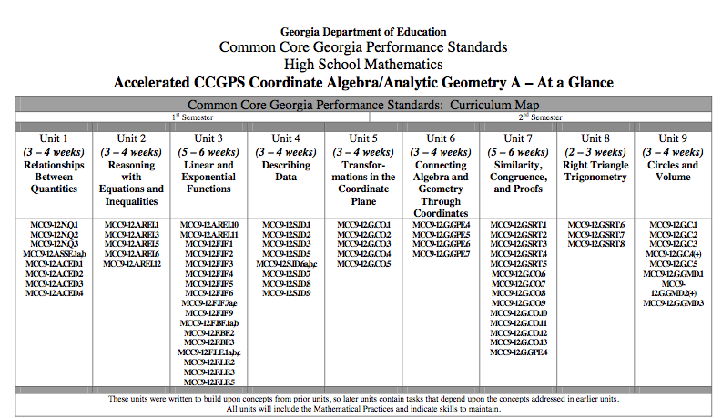
Figure 1:Accelerated CCGPS Coordinate Algebra (Grade 9)Curriculum/Pacing Guide
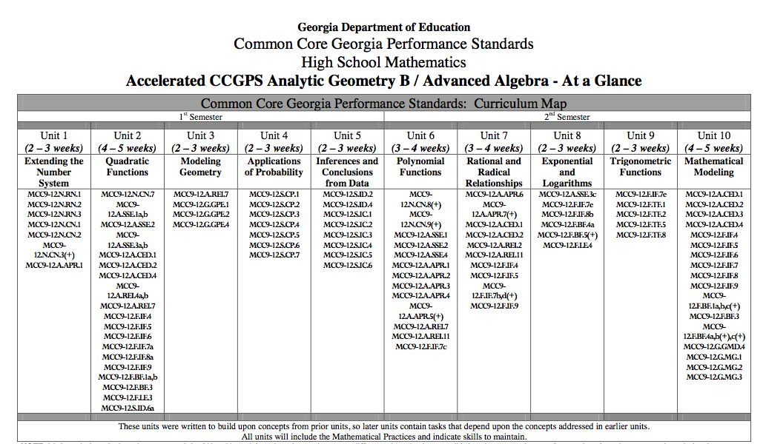
Figure 2:Accelerated Analytic Geometry (Grade 10) Curriculum/Pacing Guide
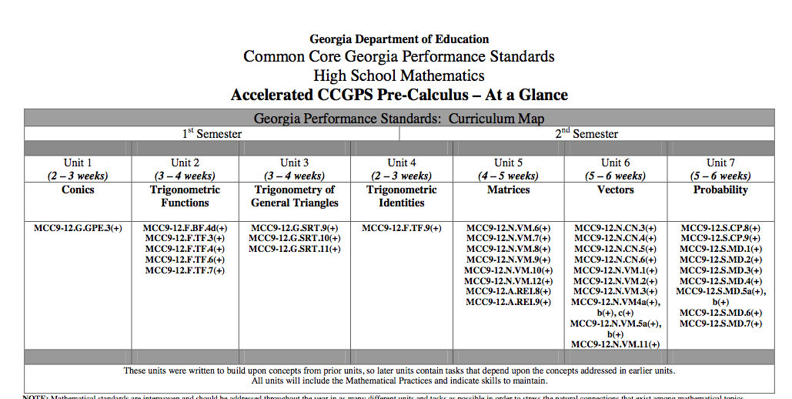
Figure 3:Accelerated Pre-Calculus (Grade 11) Curriculum/Pacing Guide
Based on the current standards, 9th grade accelerated students should be tasked with items like plotting statistical data in different formats, understanding scattered plot data sets and regression analysis, and interpreting different formats of statistical data in Unit 4. These types of activities connect well to Unit 3 in the curriculum, as students have just finished depicting and describing linear and exponential functions.

The only item students could accomplish from the current curriculum map in 9th grade occurs after Unit 9 when students can interpret circle area and understand construction of each prize segment on the spinner circle. They most likely will not understand how to obtain the angle measures of each prize segment without some additional help from the instructor.

In the new curriculum plan, students would need elements from the accelerated 10th grade Analytic Geometry (Unit 4) and 11th grade Pre-Calculus (Unit 7) to be able to calculate various probabilities. The idea of finding and interpreting expected values comes in the 11th grade curriculum.

What mathematical knowledge would they need to have covered in the course to be successful in this task?

Students would require knowledge and lessons from the following CCGPS standards for the Accelerated path:

9th Grade Accelerated Coordinate Algebra:
- MCC9-12.G.C.5: Derive using similarity the fact that the length of the arc intercepted by an angle is proportional to the radius, and define the radian measure of the angle as the constant of proportionality; derive the formula for the area of a sector.
10th Grade Accelerated Analytic Geometry:
- MCC9-12.S.CP.1: Describe events as subsets of a sample space (the set of outcomes) using characteristics (or categories) of the outcomes, or as unions, intersections, or complements of other events (“or,” “and,” “not”).

- MCC9-12.S.CP.2: Understand that two events A and B are independent if the probability of A and B occurring together is the product of their probabilities, and use this characterization to determine if they are independent.

- MCC9-12.S.CP.3: Understand the conditional probability of A given B as P(A and B)/P(B), and interpret independence of A and B as saying that the conditional probability of A given B is the same as the probability of A, and the conditional probability of B given A is the same as the probability of B.

- MCC9-12.S.CP.6: Find the conditional probability of A given B as the fraction of B’s outcomes that also belong to A, and interpret the answer in terms of the model.

- MCC9-12.S.CP.7: Apply the Addition Rule, P(A or B) = P(A) + P(B) –P(A and B), and interpret the answer in terms of the model

11th Grade Accelerated Pre-Calculus:
- MCC9-12.S.CP.8: Apply the general Multiplication Rule in a uniform probability model, P(A and B) = [P(A)]x[P(B|A)] =[P(B)]x[P(A|B)], and interpret the answer in terms of the model.

- MCC9-12.S.CP.9: Use permutations and combinations to compute probabilities of compound events and solve problems.

- MCC9-12.S.MD.5: Weigh the possible outcomes of a decision by assigning probabilities to payoff values and finding expected values.

- MCC9-12.S.MD.5a: Find the expected payoff for a game of chance.

Changes I would make to the task:

1. The first note I would like to make is a bit of a picky one. I understand that the previous task have students exploring, discussing, and playing with spinners that are already made (making a bit of a reference to theoretical vs. experimental probability in questions asked). The issue is that in the process of reverse engineering these problems sets with this particular task is that students are given information to calculate experimental probability and are to just assume that the experimental probability matches the conceptual probability exactly after 100 trial spins (samples).

The problem makes no mention that the spinner being tested is unbiased. If I were to be modest and utilize a confidence interval of 90% with an acceptable margin of error of 5%, I would require the following number of trials to test if the spinner was biased:
 | Experimental Probability | Required Sample Size
$0 | 0.3 | 228
$100 | 0.1 | 98
$200 | 0.15 | 138
$300 | 0.2 | 174
$400 | 0.1 | 98
$500 | 0.1 | 98
$600 | 0.05 | 52

As you can see, the I would need to spin the wheel 228 times in this case. While I understand that students will not be doing the required sample size calculation, nor would they point out or comprehend this until AP Statistics, I think it is extremely important for students to understand the difference between experimental and theoretical probabilities and point out the fact that I cannot just test any spinner 100 times and assume that my sample is going to reflect the population of all spins on that particular spinner. Based on this, I think the task verbiage should be altered and there should be some high level discussion of the concepts above within the task, otherwise, technically designing the spinner used in the potential student errors could actually be correct!

2. Another modification I would make is to eliminate the portion of the task in which students are constructing their own spinners. While I love the idea of connecting the idea of spinner construction to review 9th grade curriculum, I feel that the task will be too time consuming and will retract from the overall goal of the lesson.

I have included a gsp spinner file that I have created (spinner.gsp). I have also included an excel file (spiner_task_worksheet.xls) for students to document the gsp spinner results in. The excel file also has 100 spin simulator using the random number generator that updates with the click of a button by the student. With these tools, students could quickly conduct the 100 trial experiments on their own. These tools will also help reinforce the idea of variance found by experimental probability versus theoretical, and will aid students in understanding what expected value actually means. We could also expand the assignment beyond the curriculum to discuss sampling distribution by collecting and discussing multiple student results from playing the game 100 times, or allowing students to quickly capture multiple samples with the excel random number generator. While this might detract from the original goal of the unit, it might be a nice add in or connection for students planning to take AP Statistics next year.

3. If the intent is to provide the task to students before providing the appropriate curriculum lessons (as introduction to the unit), the task might need a bit more scaffolding or examples for students to work off of. For example, the task might need tree diagrams or tables built in to help students arrive at solutions. Students may need a reminder on what p-value as well.

4. If the task is assigned to 11th graders, I would also ask students to calculate the probability of arriving at a prize of $300 on the first spin AND having a total prize from two spins of $600 or more (question c). I would then ask the students to clarify why their answers were different.

5. I also think it would be nice to ask students to try to calculate the probability that the spinner will first on the $600 prize on the 2nd spin, on the 3rd spin, on the 4th spin, etc. I would also add a question in which it asks for the probability of obtaining a $100 prize, a $300 prize, and a $600 prize in three spins in which order does not matter. I think it is a nice connection to use the same activity to find different kinds of probability and this might help students in future probability questions.

6. The game instructions should be more descriptive and include a few examples with graphics. This will help any visual or ELL learners and avoid confusion, which will detract from the value of the task.

7. I would add an open-ended question to the task asking students to define what expected value is in their own words. I would also ask students to write how they arrived at different answers and why those calculations worked. From my experience in student teaching, students struggle with conceptual understanding, vocabulary, and being able to write about the math they are performing. Building more open ended questions that required sentences to answer would help improve this deficiency in students.

8. Some extensions to the task that cover other standards are to have students come up with their own game and spinner, or to have students start to discuss how one design a spinner simulator using a random number generator.

REFERENCES

Georgia Department of Education. (2014, July 1). Common Core Georgia Performance Standards for Accelerated Analytic Geometry. Retrieved April 19, 2015, from https://www.georgiastandards.org/Common-Core/Common%20Core%20Frameworks/CCGPS_Math_9-12_Accel-CoorAlgebra-Geometry_CurriculumMap.pdf

Georgia Department of Education. (2014, July 1). Common Core Georgia Performance Standards for Accelerated Coordinate Algebra. Retrieved April 19, 2015, from https://www.georgiastandards.org/Common-Core/Common CoreFrameworks/CCGPS_Math_9-12_Accel-GeometryB-AdvAlgebra_CurriculumMap.pdf

Georgia Department of Education. (2014, July 1). Common Core Georgia Performance Standards for Accelerated Pre-Calculus. Retrieved April 19, 2015, from https://www.georgiastandards.org/Common-Core/Common CoreFrameworks/CCGPS_Math_9-12_Accel-PreCalculus_CurriculumMap.pdf

